**DAILY ONLINE ACTIVITIES SUMMARY**

|  |  |  |  |  |  |  |  |  |
| --- | --- | --- | --- | --- | --- | --- | --- | --- |
| **Date:** | **05/06/2020** | | | | | **Name:** | **Archana J C** | |
| **Sem & Sec** | **4th**  **‘A’** | | | | | **USN:** | **4AL18CS011** | |
| **Online Test Summary** | | | | | | | | |
| **Subject** | | **Data Communications** | | | | | | |
| **Max. Marks** | | **30** | | **Score** | | | **25** | |
| **Certification Course Summary** | | | | | | | | |
| **Course** | **Python and Django full stack web developer bootcamp** | | | | | | | |
| **Certificate Provider** | | | **Udemy** | | **Duration** | | | **2hours** |
| **Coding Challenges** | | | | | | | | |
| 1. **Write a program in C to rotate an array by N positions.** 2. **Write a Java Program to find the second-highest number in an array.** | | | | | | | | |
| **Status: Completed** | | | | | | | | |
| **Uploaded the report in Github** | | | | | **Yes** | | | |
| **If yes Repository name** | | | | | **https://github.com/alvas-education-foundation/archana_j_c** | | | |
| **Uploaded the report in slack** | | | | | **Yes** | | | |

Online Test Details: (Attach the snapshot and briefly write the report for the same)

The online test was from module 5, which was about other wireless networks like cellular telephony, satellite networks, network layer-protocols etc.. There were 30 questions and the duration was45 minutes. The questions were optimal. The score that I got in the test is 25/30.

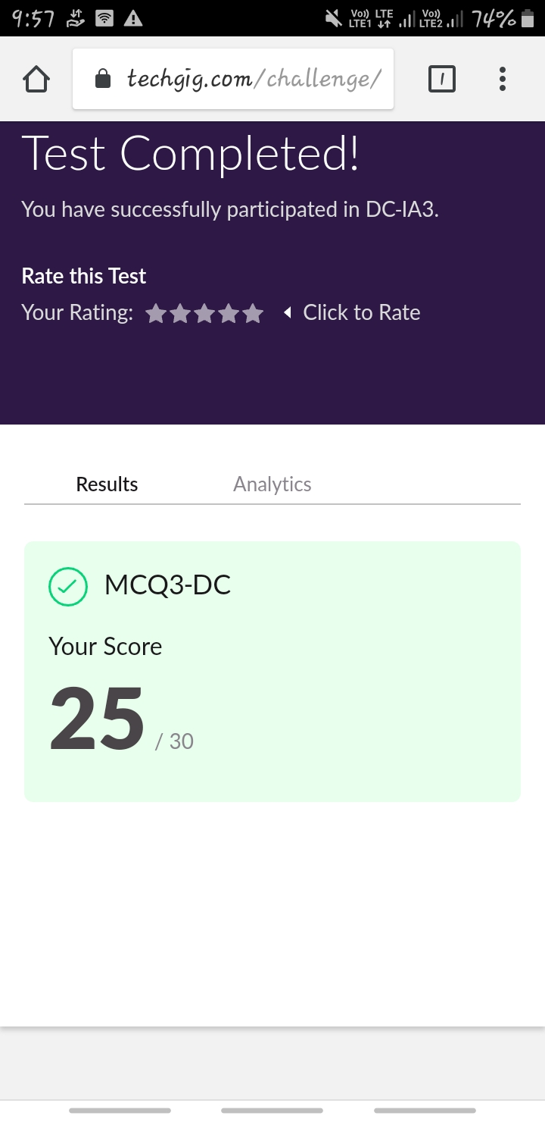

Certification Course Details: (Attach the snapshot and briefly write the report for the same)

COURSE NAME : **Python and Django full stack web developer bootcamp**

CERTIFICATION PROVIDERS : Udemy

The course is all about the web development. I was learnt about html and css, and how to code using html and I’m know in javascript.

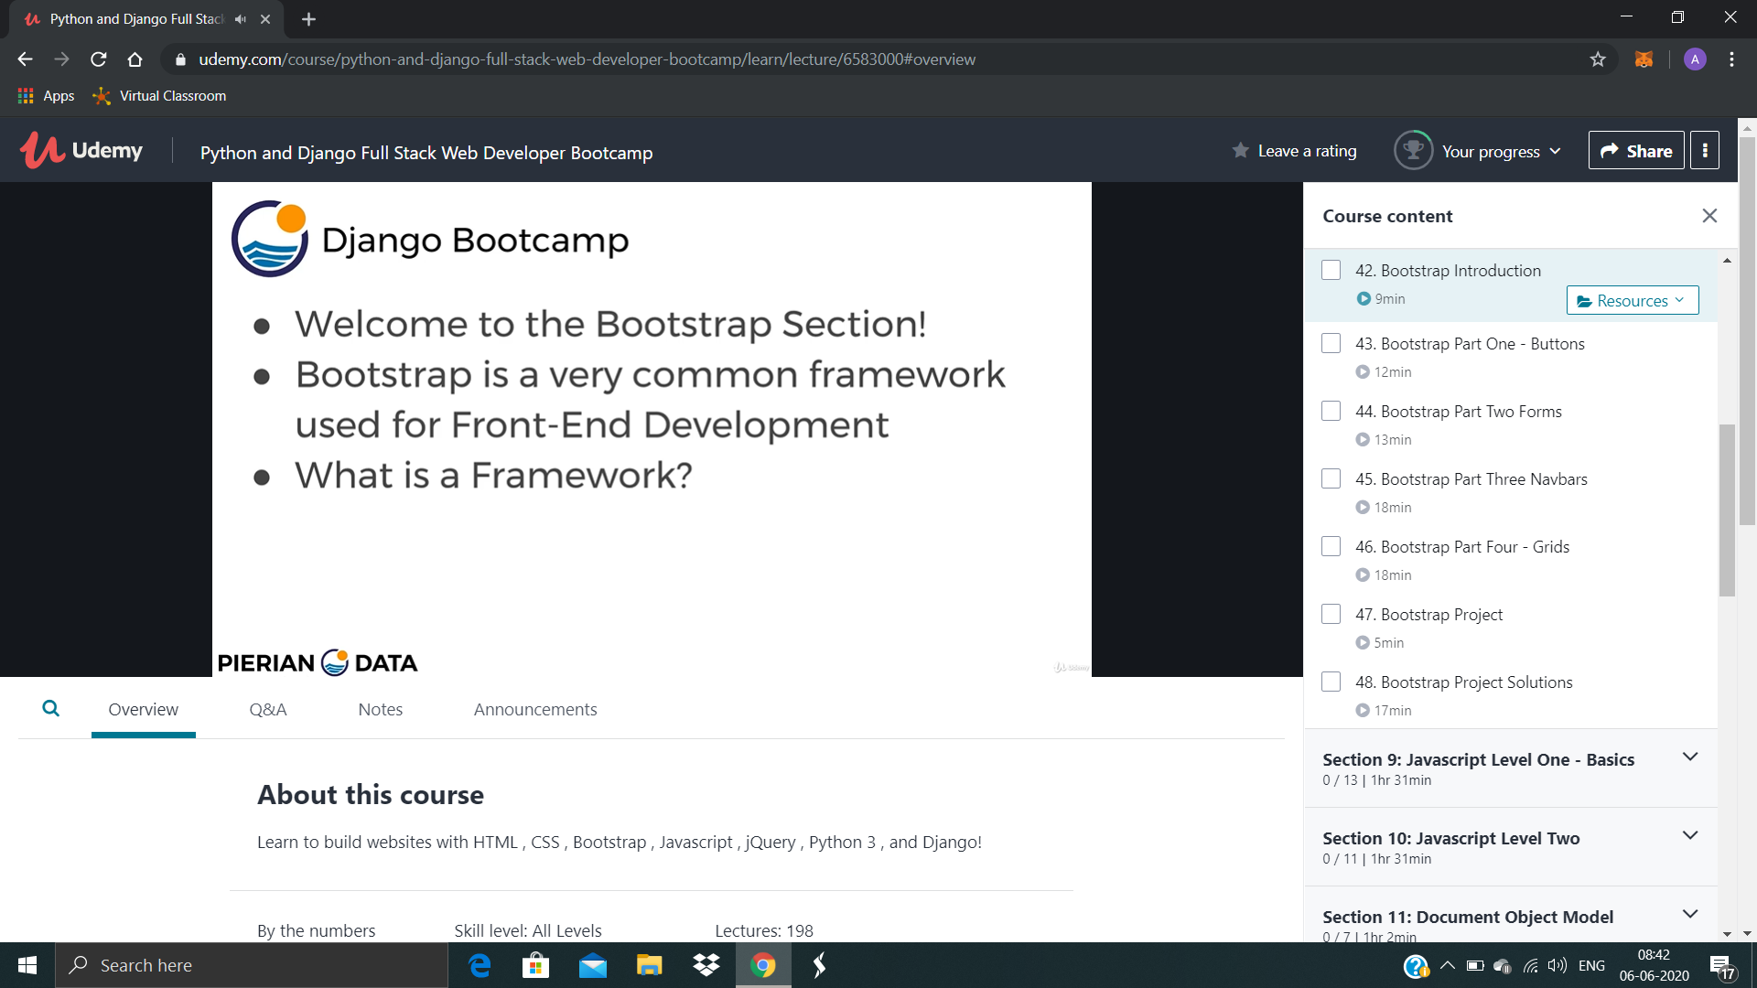

Coding Challenges Details: (Attach the snapshot and briefly write the report for the same)

Today I’m done with some java and python programs. The solution are already uploaded in github repository

**Program1 : Write a program in C to rotate an array by N positions.**

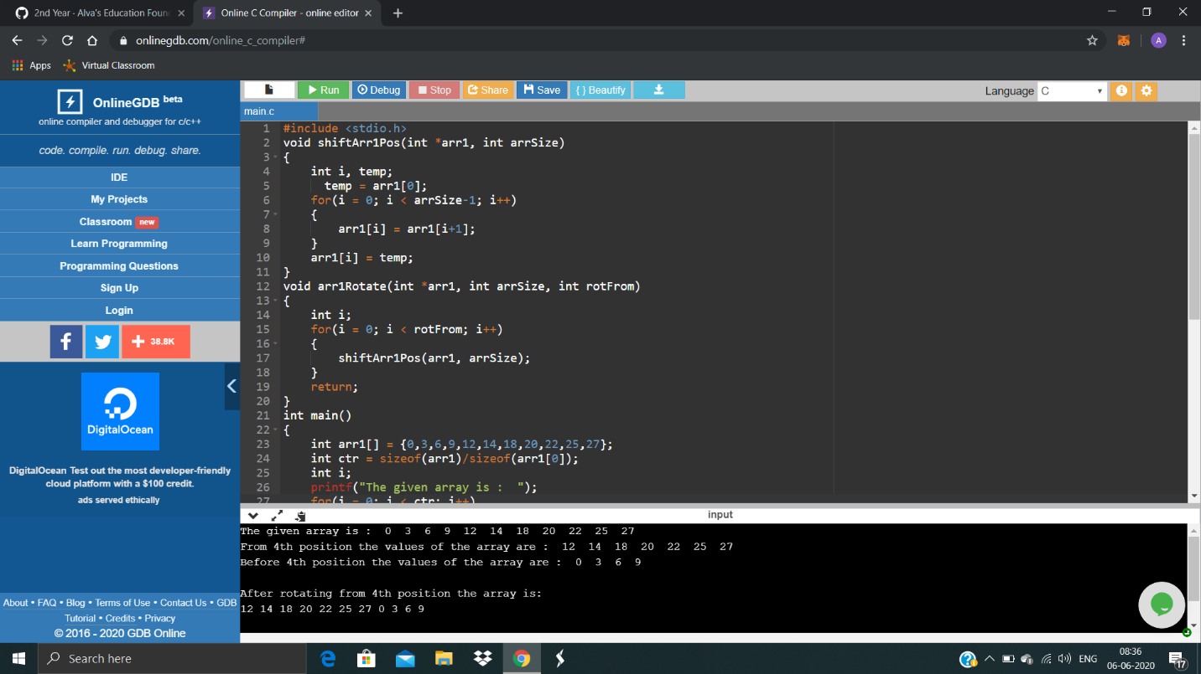

**Program2 : Write a Java Program to find the second-highest number in an array.**

